**DIGITAL IMAGE PROCESSING COURSE - 505060   
PRACTICE LABS**

**LAB 07. REVIEW EXERCISE**

**1. Do unfinished assignments in previous labs.**

**2. Number Bounding Boxes Detection**

Given an image of numbers in black color on a white background. The input image may be affected by noise such as disconnected parts of each number, cluttered background …

Your goal is to make a Python program drawing the bounding boxes of each digit appeared in the given image. A bounding box of a digit is a rectangle enclosing the digit entirely.

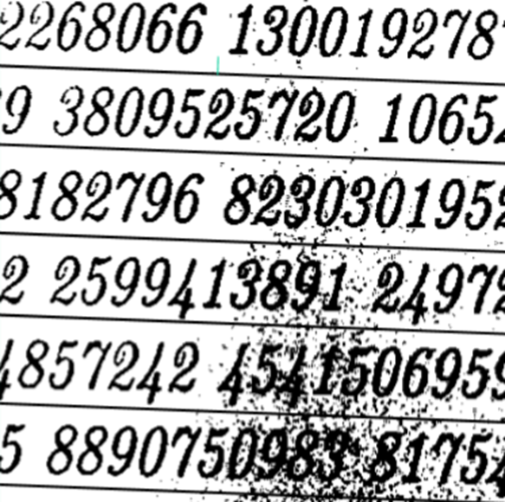

**Input**: a color image (JPEG / PNG)

**Output**:

(1) the original image with digit bounding boxes shown in red color (output.jpg)

(2) a text file in which each line including each bounding box information (the top-left coordinates, width and height of each detected bounding box separated by a space character) (output.txt)

**Algorithm**: Any of algorithms or any of OpenCV functions

**Grading:** Points = Number of TRUE detected bounding boxes / Number of all digits

**Submission**: Python code + output files via Google Classroom

Output sample:

